The oak is the king of the vegetable world, is a majestic tree, tall, strong and durable.
The oaks are spread all over the world, especially in temperate regions of the north of the hemisphere , up to 1000 meters.

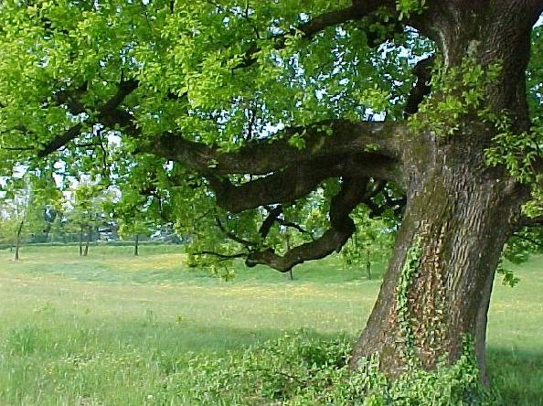  Rovere (Quercus Ilex) | The tree’s family includes about 600 species of oaks.  The oaks usually have a sturdy trunk covered with a hard, rough bark, which splits into numerous branches which form a huge canopy.

The roots of the tree branch out both in depth on the surface, so the plant remains anchored to the ground.  The oak wood is used for its resistance, in particular the oak that is suitable for marine structures, building beams and railroad ties.  The oak is also used in cabinetry or as material for furniture, barrel staves, flooring and veneers. | 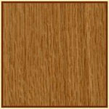  Legno di rovere

The bark of some oaks has been used in medicine, tanning and coloring.
The fruit of the oak is the acorn that changes shape from species to species.
Acorns have been used for a long time for the feeding of pigs and to get the tannin, used as a dye.

Holm  LEAVES: from a strictly elliptic ovate, 7.5 cm long and 5 cm wide, or so toothless, dark green and glossy on the upper side, gray and hairy underneath.  BARK: almost black and wrinkled.  FRUIT: a acorn, up to 2 cm long, for 1 / 3 enclosed in the dome.  AREA OF ORIGIN: Mediterranean.  HABITAT: in the hills, woods and dry places.  HEIGHT: 30 m | 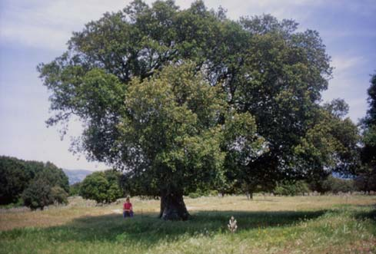  Holm

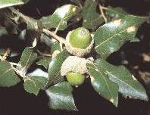  Ghianda di leccio | Oak  Leaves: elliptic to 12 cm wide and up to 7.5 cm, with rounded lobes, dark green, smooth and slightly glossy above and paler below with a thin fuzz.  BARK: gray, with vertical slits.  FRUITS: acorn to up to 3 cm long for 1 / 3 enclosed in a dome.  AREA OF ORIGIN: Europe.  HABITAT: In woods.  HEIGHT: 40 m

Red Oak  Leaves: elliptical, ovate, obovate, up to 20 cm long and up to 15 cm wide, with lobes slightly toothed, dark green, opaque and smooth on the upper side, pale with brown hair over the lower ribs, red-brown in autumn.  BARK: gray and smooth, very old carved in oak.  FRUITS: A acorns, 3 cm long, closed 1 / 4 in a shallow dome.  AREA OF ORIGIN: Northeast America.  HABITAT: In woods and mountains.  HEIGHT: 25 m | 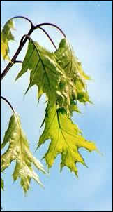  Red Oak leaves

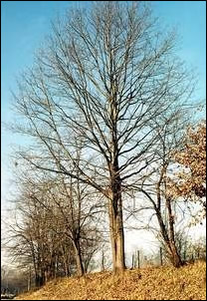  Red Oak |  | 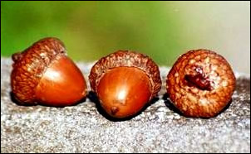  Red Oak fruits

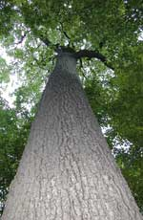  Black Oak | Black Oak  Leaves: ovate to elliptic, 25 cm long or more and 15 cm wide, with 5 or 7 pointed lobes, dark green, smooth, shiny above, pale and hairy beneath in young leaves.  BARK: dark brown furrows.  FRUIT: a acorn, 2.5 cm long, half enclosed in the dome.  AREA OF ORIGIN: Eastern North America  HABITAT: In dry woods and sand dunes  HEIGHT: 25 m

White Oak  LEAVES:. obovate, 20 cm long and 10 cm wide, tapering at the base, very sharp in 2 or 4 lobes on the second page, glossy green on the upper side, blue-green on the lower, purple-red in autumn.  BARK: Pale gray, scaly, cracked with age.  FRUIT: a acorn, 2.5 cm long, closed 1 / 4 in a wrinkled dome.  AREA OF ORIGIN: Eastern North America  HABITAT: In dry forests  HEIGHT: 35 m | 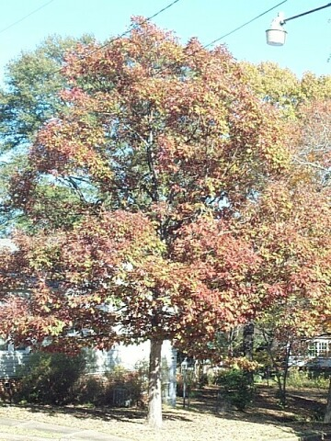  White Oak

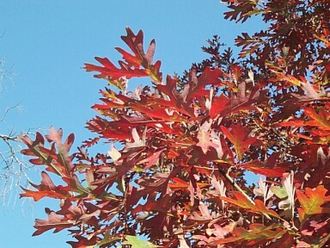
White Oak leaves

